**Project name: Healthfirst Care initiative**

**Risk Management Plan**

**Risk Register- Image & File**

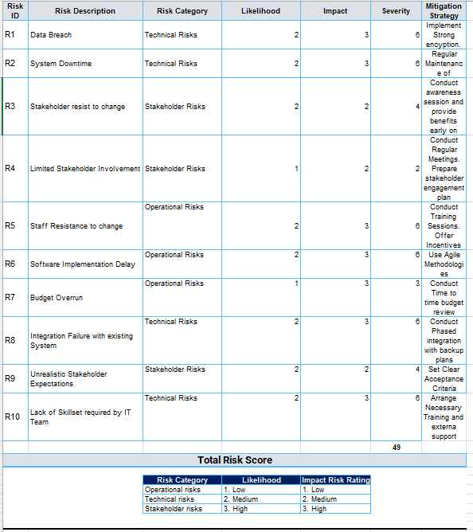

**Risk Assessment Matrix- Image & File**

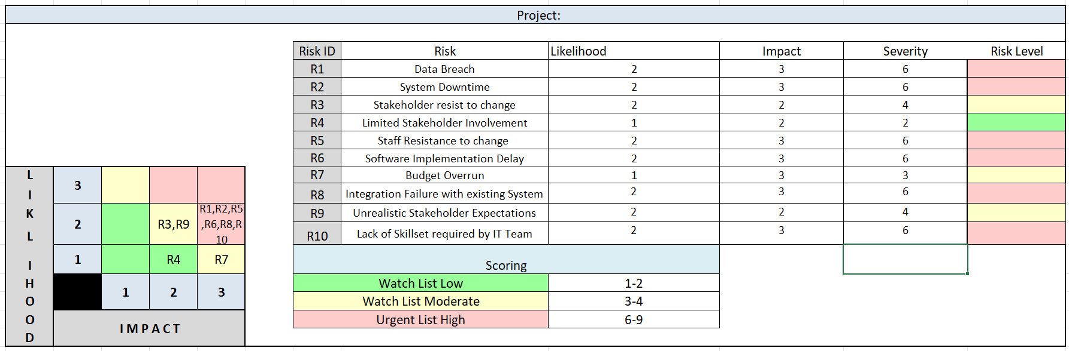

**SWOT Analysis**

|  |  |  |  |
| --- | --- | --- | --- |
| **I**  **N**  **T**  **E**  **R**  **N**  **A**  **L** | **Strength** | **Opportunity** | **E**  **X**  **T**  **E**  **R**  **N**  **A**  **L** |
| 1. **Strong leadership support.** 2. **Qualified and Experienced Medical Staff.** 3. **Highly skilled IT Team.** 4. **Existing experience with healthcare operations.** | 1. **Process automation.** 2. **Enhance patient satisfaction.** 3. **Staff upskilling and digital literacy programs.** 4. **Use of data for decision-making and future improvements.** |
| **Weaknesses** | **Threats** |
| 1. **Manual workflows in appointment and check-in processes.** 2. **Lack of effective inter-department communication.** 3. **Inefficient resource allocation.** 4. **Limited digital skills and dependence on manual processes.** | 1. **Data security risks (data breaches).** 2. **Stakeholder resistance to change.** 3. **Budget overruns during implementation.** 4. **Potential integration challenges with existing hospital IT systems.** |

**Summary of Strengths, Weaknesses, Opportunities, and Threats**

**Strengths**

* The organization benefits from **strong leadership support**, helping to drive project success.
* **Highly skilled doctors and IT professionals** are available, ensuring operational excellence.
* There is **prior experience in healthcare operations**, which makes handling workflows easier.

These strengths can help overcome challenges and **support smooth project execution**.

**Weaknesses**

* **Manual workflows** are still used, leading to delays and mistakes.
* **Communication gaps** between teams can cause misunderstandings or project delays.
* **Limited digital skills** among staff make new technology adoption harder.
* **Inefficient resource allocation** could waste staff time and resources.
* **Reliance on manual processes** can slow down healthcare service delivery.

These weaknesses could **slow progress** if not addressed properly during implementation.

**Opportunities**

* The project offers a chance to **automate processes**, reducing errors and improving efficiency.
* There is a strong opportunity to **enhance patient satisfaction** by improving healthcare delivery.
* **Training and digital skill-building** programs can make staff more comfortable with new systems.
* By collecting and analyzing data, the organization can make **better decisions** for the future.

These opportunities can help **transform operations** and improve healthcare services.

**Threats**

* There are risks of **data breaches** or loss of sensitive information if security is not improved.
* **Stakeholder resistance to change** could block or delay implementation.
* There’s a risk of **budget overruns** if costs are not monitored closely.
* Integrating new systems with **existing tools** might cause technical problems.

These threats can **harm the success of the project** if not carefully managed.